The Fritillaria Group

Membership Application Form
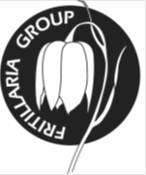 | Members Benefits  Two journals annually  Expert speaker programme  Access to seed of many species
Annual membership (renewable 1st October)
Single £8 – Family £10 – Europe £10 – Elsewhere £12

To join the Group please complete and send this form,
together with a cheque payable to The Fritillaria Group, to:

The Treasurer
The Fritillaria Group
24 Leven Road
Yarm
TS15 9JE

Mr/Mrs/Miss/Ms
First name
Family Name
Address
Postcode
Email address (important for Seed Distribution)

